NAVAL SHIP BATTLES DESIGN (CLIENT)

A CIS*3750 Design Document

Introduction

The design decisions for the client side of the project will be outlined in the following documents. Contained within are a mix of class descriptions, higher level views of our design decisions and applicable diagrams. Using a pseudo Model-View-Client design process, the project will use an object oriented paradigm to allow the code to be reusable and changed easily and without effort.

Design Overview

The design of this program will consist of the main class (Client) which splits off into other classes to accomplish different tasks which is designated to it. The Client class creates a Controller, GUI, and Connect class. These 3, and the Client class, is the basis of the entire program all work will stem from this program base.

A more in depth and detailed explanation of these classes will follow, however a short summary of what each does:
-Client: Manages all classes and information and does most of the information processing.
-Controller: Starts up and listens for any of the users keyboard tapping or mouse clicking, and sends it off to be processed.
-GUI: Where all drawn material will be, and is where everything is drawn to the screen. Anything that the user sees will be within this class.
-Connect: The network part of the program, where all that is being sent out and coming in will go through this class.

There are 2 classes which the Client class makes instances of which is Environment and Ships. The Environment class is where all information dealing with the map, weather, and land masses will be kept. The Ship class will essentially be a user in the game, where anytime a new user connects a new Ship class will be made. It will hold all x,y coordinates, damage, direction name and ID for each user.

Interface
The beginning of the program will have a simple pop up button for the player reading “Ready”. This button when clicked will notify the server that the player is ready to begin the game. After clicking, the player waits for the server to send over all the information to allow the program to start drawing to screen and preparing to play.
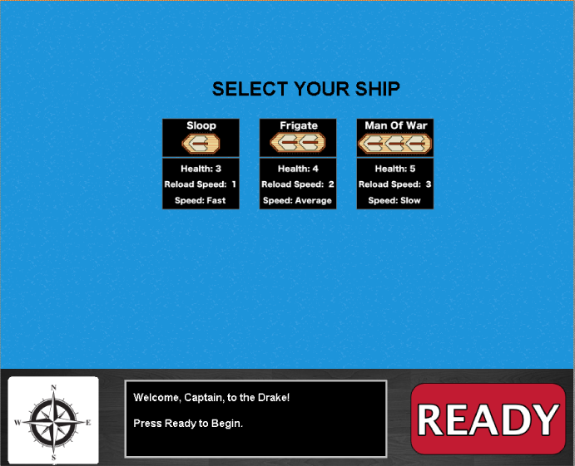

The interface of the program will be simple, but it will not leave the player at a disadvantage against other clients. At the top of the players screen will contain the player’s health, and at the bottom right hand corner of the screen will contain a compass for navigation if lost at sea. Truly revolutionizing the way games will be played, this minimalistic design does not leave the player confused with unnecessary information and leaves them to focus on one thing; winning the game by leading the brave seamen aboard ship to victory.
Select Screen When Starting Game

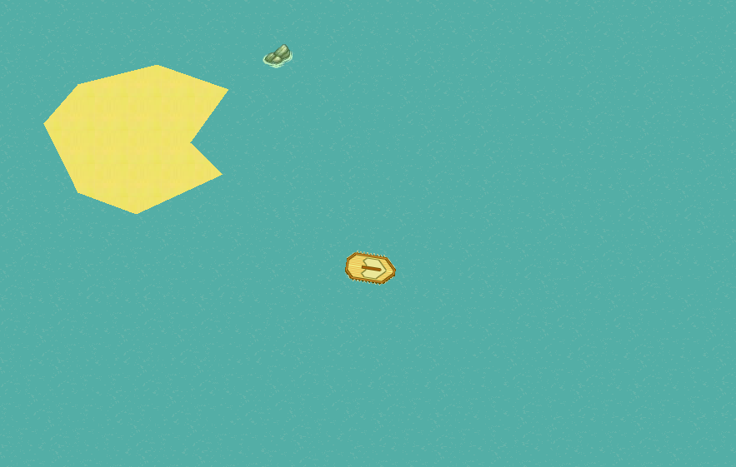
All the water around the player will be of a blue colour, and the land masses will be a sandy colour, allowing the user to imagine he is on a tropical paradise not fighting to the death with other players. The general colour of all the objects on the screen will change a hue if the time changes to dawn, or evening. The closer to evening, the darker everything begins to look.

The general input interface for the client will have the arrow keys which will allow the player to move his ship across the map, and the space button will allow the player to fire the cannon.

Sample World Graphics Image With Dawn Time Setting

Program Flow Diagram
Request Info
No Server
Verify Connection
Server Exists
User starts the program
Connect to the server

Get Information
No Server
Listen
Send Information
Draw Screen
Shutdown
Ready
Valid server
Received info from user
Terminate application
User wants to exit application
Invalid server

Begin waiting for server to say ready

Begin listening for user and server input
Server quits
Server pushes info

Server quits

Terminate application

Validate the screen

Program Flow

The general flow of the program will have the user starting up the client program. This will initialize most of the main classes in the program with the Connect class taking lead. The Connect class will try to connect to the server to request information for the program. If no server is found, we verify the information given to the program through arguments and try once more to establish a connection.

If the server is valid we begin listening for any user and server inputs for the program. Controller begins to listen on the keyboard and mouse, while Connect listens for information from the server. The GUI class begins to draw the “Ready” button, and this ready screen will loop until the button is pressed. Once pressed, Connect sends the server the ready signal and waits for input.

Connect will at some point receive all information such as the map, all players connecting, environment variables and any other variables which are needed for game play. GUI will draw all information which has been given, however it will only draw information that is in its view. Any input from the player will cause Controller to call ParseMsg which will set up a string which will be sent to Client for validation and then to Connect to be sent off.

Nothing is done client side without the server’s permission. This includes any and all movements to the player ship, any cannons fired, etc. Connect constantly waits for the server to push down the information, and when received it sends the information off to be parsed, which is where all actions will be made. GUI is constantly drawing information that is available within the Client class, using gameUpdate to be up to date.

The termination of the program relies on either the server quitting and/or telling the program to finish, which is where the program cleans up after itself and terminates. The program can also quit if the user wants to quit, which is just if the user closed the GUI window.

Class Communication

The following will contain specific delegations to each class and how it will be interacting with all the other classes. The aim is to minimize dependence on other classes; however this is sometimes sacrificed for ease of use.

Client
This client class is where all the magic happens, as it controls all information that is being used. It has most of the instances of the ships, and creates the Environment instance as well. Client calls Connect, Controller and GUI to do its bidding and allows the program to operate smoothly.

Client sends over a string to Connect whenever userInput has created a string to be sent. It receives a string from Connect when changes have been performed from server. All strings are formatted like the Communications Specifications decided as a class.

Client creates Controller, however does not send anything to it, nor directly receive anything from Controller.
ParseMsg sends over a string to Client, which consists of any of the Servers bidding.
Client instantiates GUI, however does not every receive anything or directly from GUI.

Connect
Connect is the only class that deals with the server. It sends over any information that has been sent from the Client class and sends it to the server. Whenever information has been sent to it from the server, it calls Client and sends the String to be parsed.

Other than Client and the server, Connect does not send any other information out. It only receives information from Client and the Server. The way Connect talks to the Server is using a TCP/IP connection, which is used because of it being quite reliable.

Controller
Controller only deals with keys that the user has input. Whenever the user presses a key, the controller turns that into an integer and sends it over to ParseMsg. This is the only interaction it has with other classes.

ParseMsg
ParseMsg receives information from Controller, identifies what key has been pressed and then sends it over to Client telling it what the Server must know. (E.g. moving the player). It only interacts with Client, specifically userInput.

GUI
The GUI class generally works without interacting with any class, and only displays information. It keeps up to date with GameUpdate, and uses the information from that class to draw objects properly.

GameUpdate
GameUpdate interacts with client, getting all the ships which have the speed and coordinates, the map, and the environment. GUI uses this class to keep up to date with all the information.

Class Diagram
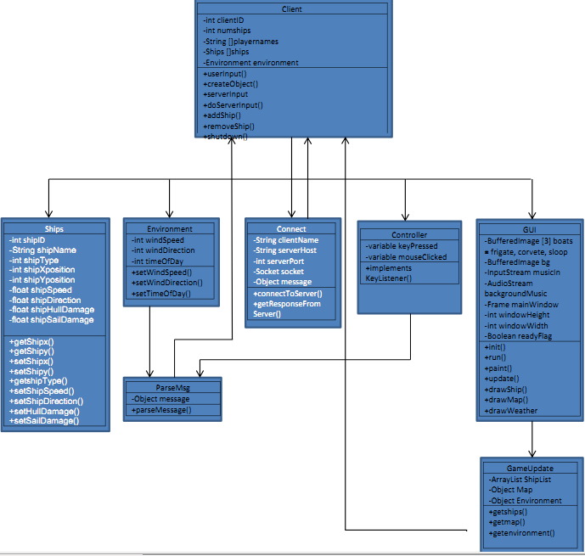

Class Index

Client Controller Ships
ParseMsg Connect Environment
GUI GameUpdate

Class Name: Client
Description: This is the main class, which is to be the Model class, where all logic is done through here and it’s successive classes. It adds and removes ships, creates objects to be sent off and delegates other tasks to classes.
Operation Name | Return Type | Description
User Input | Void | Gets information that was sent from the controller , packages it and sends it over to Connect.
Create Object | Void | Creates/Packages information into an object and sends it off to connect, so that it can be sent to server.
Add Ship | Boolean | Adds a ship to the ship list and return a Boolean value, true if successful.
Remove Ship | Boolean | Removes a specified ship from the list, and returns true upon success.
Shutdown Client | Void | Shuts down client, informs server of this action.
serverInput | Void | Takes the information from Connect, and parses it. Once parsed it does all the necessary changes that the server has sent such as updating player positions.

Attribute Name | Attribute Type | Description
Client ID | Integer | This is the ID of the client that the server has delegated to it.
Number of Ships | Integer | This is the number of ships within the game that is currently connected to the server.
Players Names | String[] | The names of all the player ships.
List of Ships | Ships[] | The list of ships, where each spot in the array is of type Ship (defined below).
Environment of Game | Environment | The environment variable, which holds all values of the map, fog, etc.

Class Name: Ships
Description: This is a class that holds all the information for the Ships, which include the position, damage, name, and ID. Each instance is for only one ship.
Operation Name | Return Type | Description
Get Ship Information | Integer [] | A get method for the ship information which returns the x, y, speed, direction and damage
Set Ship Information | Void | A set method which sets x, y, speed, direction and damage.

Attribute Name | Attribute Type | Description
X,Y Position | Integer | The x,y, coordinates for the ship.
Ship Direction | Float | The direction the ship is heading in relative to the map.
Ship Type | Integer | The type of ship it is, which can be 0-2, depending on what the user chooses.
Ship Name | String | The name of the client that controls the ship.
Ship ID | Integer | The ID of the client that controls the ship.
Ship Speed | Float | The speed of the ship it is currently going at, which is a number between 0 and 1.
Hull Damage | Float | The damage of the hull, which is a number between 0 and 1.
Sail Damage | Float | The damage of the sail, which is a number between 0 and 1.

Class Name: Environment
Description: This is an object that has all the attributes of the current environment such as wind and time of day.
Operation Name | Return Type | Description
Set Wind / Time | Void | Sets the wind speed, direction and the time of day.
Get Wind/ Time | Integer | Gets the wind speed, direction and the time of day.

Attribute Name | Attribute Type | Description
Wind Speed | Integer | An integer that ranges from 0 – 200 m.s.
Wind Direction | Integer | An integer which simulates the wind direction, going from 0-359 for N,S,W,E.
Time of Day | Integer | The time of day which can be 0-2, for Dawn, Midday and Night.

Class Name: GUI
Description: This is the class which will run and spawn all the visual aspects of the game. It will draw a background, ships, the islands, fog, UI and anything the user will see. Music will also be running within this class.

Operation Name | Return Type | Description
Runnables | Void | This collection of classes is everything runnable asks to be implemented. Consists of init, run, paint, and update.
Draw Ship | Void | This draws all the ships that are in view.
Draw Map | Void | This draws the map portion that is currently in view.
Draw Weather | Void | Draws the weather graphics such as fog and rain.

Attribute Name | Attribute Type | Description
ShipList | BufferedImage | Has the image of all the boats, which consists of Frigate, Man Of War and Sloop.
Background | BufferedImage | Has the image of the background for the entire map.
Music | AudioStream | Custom music written by a group member to be looping while playing the game.
Main Window | Frame | The main window that is part of JFrame and has everything that is viewed in here.
Window Height and Width | Integer | The height and width of the window.

Class Name: GameUpdate
Description: This is a class which keeps all the information for GUI update and accurate. It grabs the information and stores it within this class so GUI can use it.
Operation Name | Return Type | Description
Get Ships | Ship [] | Get the ship list from the Client class for the GUI.
Get Map | Object | This grabs the map that is viewed within the Frame.
Get Environment | Environment | Gets a copy of the environment from the Client class.

Variable Name | Variable Type | Description
Map | Object | This is the object that stores the map that is viewable.
Player Environment | Environment | This is the environment that is a copy of the variable within Client.
Ship List | Ship [] | This is an array of ships; it copies the array which is available within Client.
Class Name: Controller
Description: This is the class that handles the input, either through mouse or keyboard, by the user.
Operation Name | Return Type | Description
Key Listener Implementation | Integer | This is the implementation for Javas KeyListener class, which waits for and catches any user input. It then returns an integer signifying the key pressed.

Variable Name | Variable Type | Description
Key Pressed | KeyPressed | This is the variable that catches user input.

Class Name: Connect
Description: All port and socket information is within this class. Anytime the server sends us an update, this class catches it and sends it off to the main class. Whenever the program must send off something to the server, Connect sends it off.
Operation Name | Return Type | Description
Connect To Server | Boolean | Connects to the server and returns true is it worked, and false if it failed, citing a reason.
Get Response From Server | Boolean | Waits for a response from the server and sends off the response to ParseMsg.

Variable Name | Variable Type | Description
Client Name | String | The client name, which is what the client is called.
Server Host | String | The host name that the client connects to.
Server Port | Integer | The port that the client connects to.
Socket | Socket | The socket is uses to connect to the server.
Message | Object | The message that is sent to the server signifying different actions, such as firecannon.
Class Name: ParseMsg
Description: This parses all messages sent to it so that they can be sent over to the server and can be understood by the server. It must be formatted properly and must be a type which can be sent over the socket.
Operation Name | Return Type | Description
Parse Message | Object | Takes in information that must be sent over to the server, and formats it in such a way that the client will know what to do.

Variable Name | Variable Type | Description
Message | Object | This is the message that will be sent over to the Connect class to be sent.

Server Communication
During the running of the client program, communication between the server is key. There is always information being sent back and forth, either to update a ship position or to notify that it is day out. All messages sent between the server and the client are in the form of Strings, which are parsed in the form of “<Message Name” “Values”>, with message name being the name of the message itself and values being the information separated by spaces.
Client to Server Messages
FireCannon
If a user presses the space bar while in game, this initiates the FireCannon message. The Controller sends the information to Client and the Client parses the message into:
FireCannon <int> <int>
Arguments: The first argument is the shipID, the second argument is the position of the ship which can be between 0 and 2: 0 – Sail, 1 – Hull, 2 – Deck.
ChangeSpeed
When the user presses the up or down arrow keys the user wants to ship speed to be changed.
ChangeSpeed <float>
Arguments: The value which will take on the float will be the amount the boat will change it’s speed by, which is 0-1. 1 is the maximum amount of speed the boat will be travelling, and each time the player presses the up arrow the speed is incremented by 0.1.
SetHeading
To change the direction of the ship the user presses either the left or right arrows, which changes the ships position by 20 degrees each time the arrow is pressed in either direction. Positive values are starboard, negative values are port.
SetHeading <int>
Arguments: The integer value is between -180 and 180, which corresponds to the direction the map is heading relative to the top of the map.
Register
This registers the player for the server, sending the name of the ship and what type it is. This is initiated when the program starts.
Register <int> <String>
Arguments: The integer is a value for the ship type, which can be 0-2 depending on the ship type. The name is a string provided by the player in the start of the program.
SetReady
This notifies the server that the client is ready to play. This is initiated when the player presses the ‘ready’ button.
SetReady <Boolean>
Arguments: The Boolean value is whether the player is ready or not, which depends on when the player pressed the ‘ready’ button.
Quit
Used when the client quits the game, so that the server can neatly clean up.
Quit
Arguments: None.

Server to Client Messages
Wind
Used when the wind speed and direction has changed. The values are changed within the Environment class.
Wind <int> <int>
Arguments: The first argument is the speed, which is measured in meters per seconds. The second argument is a direction the wind is blowing, which is 0-359 which corresponds to the degrees on a compass (0 being North, 180 being South).
Fog
When fog is received from the server, the value of fog is changed within Environment. In GUI it draws a grey image over everything making it look foggy.
Fog <int>
Arguments: The value can be 0 or 1, 0 is off 1 is on.
Rain
When rain is on, the GUI begins to draw small droplets of rain over everything. Smooth jazz may start to play in the background for ambience (maybe not.)
Rain <int>
Arguments: Value is 0 or 1, for off and on respectively.
StartGame
When the player receives this, the program breaks out of the while loop it was in when it was waiting for the server to send this. It begins to draw all elements to screen and instantiates all variables and ships within the program. After this, the program will begin reading in most of the information about the map, environment and players.
StartGame
Arguments: None.
SetActiveShip
This tells the client what ID it is in control of.
SetActiveShip <int>
Arguments: The integer is the ID of the ship.
Shore
This tells the position of the shore line within the map area, which is a polygon. The GUI will be drawing the shoreline on the map for the player to see.
Shore <int> <int> <int> *
Arguments: The first integer is the number of vertexes in the polygon and the rest of the integers correspond to x,y positions for each point.
Time
This lets the client know what time of day is, and each time of day will change the hue of the screen. The hue will change depending on how late or early it is in the day.
Time <int>
Arguments: The integer can be any number from 0 to 2, corresponding to Dawn, Midday and Night respectively.
SetShipInformation
This describes when a ship has come into view for the client and in visible range. In the program, GUI begins to draw the ship on screen after receiving information from Client. This also allows the player to fire onto the enemy ship.
SetShipInformation <int> <int> <int> <float> <float> <float> <float>
Arguments: In order the arguments are:
-ID of the ship
-X coordinate relative to map
-Y coordinate relative to map
-Speed of boat in knots
-Direction of boat (-180 to 180) relative to North
-Hull Damage (0.0-1.0, 1.0 being in perfect condition)
-Sail Damage (0.0-1.0, 1.0 being in perfect condition)
Add Ship
This adds a new ship to the playing field, where each time the client receives this message the Client class will add a new instance of a Ship with the arguments from the message. The GUI draws the new ship if it is ever in view.
AddShip <int> <String> <int> <int> <double> <int> <int><float>
Arguments:
-ID of the ship
-Name of ship
-Ship type
-X position of the ship relative to the top left corner
-Y position relative to the top left corner
-Rotation of the ship (0.0-359.0) in degrees
-Start of the time the ship moved at
-Speed which is the ship is moving at
Remove Ship
Removes an existing ship from the playing field, if a client has disconnected or was destroyed. Client gets rids of the ship in all lists, as well as the name and the ID of the ship.
RemoveShip <int> <String>
Arguments: The integer is the ID of the ship, the string specifies the reason it was removed.
Shot Fired
This notifies the client that a ship has fire at another.
ShotFired <int> <int> <int>
Arguments: The arguments are the ID of the ship, the target ID of the ship and whether the ship hit or not (0,1), respectively.
Set Ship State
This changes the state of a ship in the list of active ships. Any values can be changed for the specified ship.
SetShipState <int> <float> <float> <float>
Arguments: The ID of the ship is the first argument followed by Sail and Hull health and speed as the last argument (All 3 range from 0.0 to 1.0).
Shut Down
This informs the client the server has shut down, so that everything can be cleaned up. A message would be shown to the user that the game has ended and will shut down. Everything within the program is cleaned up.
ShutDown
Arguments: None

Glossary
Sloop - a warship of the old sailing class, having a flush deck and usually one tier of guns.
Frigate - a fast naval vessel of the late 18th and early 19th centuries, generally having a lofty ship rig and heavily armed on one or two decks.
Man Of War - a ship built or armed for combat purposes with multiple levels of cannons, usually 100 or more
Server - a computer that makes services, as access to data files, programs, and peripheral devices, available to workstations on a network.
Client - a workstation on a network that gains access to central data files, programs, and peripheral devices through a server.
MVC - A type of design pattern used in programming, it stands for Model-View-Controller. Splits up the programs design into a model for information, a view for anything seen and controller for anything input.
(n.d.). Retrieved from http://dictionary.reference.com
Sources
Wood Panel taken from http://zygat3r.deviantart.com/art/Dark-Wood-58266349
Compass taken from http://www.dreamstime.com/royalty-free-stock-image-compass-rose-illustration-image4389596

Implementation Report
Of A Naval Battle Client

Testing Methods

-There were numerous ways in which we had tested our program to make sure everything was working properly. Testing was done within our own group, and with other server teams to identify any errors within our code. The main server used for testing was Toulous, although Portsmouth and Trafalgar was also used to compensate for the lack of implementation in some respects during the testing phase.
-Within the group we had done both blackbox and whitebox testing. For the server to client connections, and vice versa, we had set up a temporary server that would receive and send out messages. This was done first to test simple network connections so it would read and write to and from a server. Later on, we made the server more complex by allowing it to send over polygons, so that we could test the shore message, and so that it would send over messages for moving the ship. Since we had written our messages, testing to see if the protocol was correct was a bit biased.
-Testing the algorithms for smooth moving and making sure the classes talked to each other properly were accomplished by running our classes by themselves to see if they would accomplish what we set them out to do, and then within the context of the program to make sure the classes properly sent and received each other information. Sometimes the classes ran into a deadlock waiting for each other, but one was waiting for the others information.
-For debugging println statements were used, as well as the Netbeans built in debugger to trace through the program and threads running.
-Once we had a server group that was up and running we began to properly test communication messages and making sure that each end was sending the messages in proper order and that they were formatted properly. Checks were put in place on our side so that if the client sent a message at the wrong time, or it was improperly formatted we would continue on with the program, using the information that they had sent us. Simple things such as using colons and semicolons interchangeably are an example of a way we had to catch such errors.
-Graphics were tested once most of the backend of the program was done and we were able to start sending and receiving messages to do with moving, other clients’ ships, a ships demise, etc. Being able to incorporate smoothly moving ships was a large factor within our program. An algorithm was developed to check to see if there was a discrepancy between the server and client in how far the ship was supposed to move in a given second. This algorithm can be turned on and off, and in doing so will be able to check to see if our client is doing the calculations wrong or if the server is.
-We also had people who were not too familiar with computers come in and test our program. We found that these people found it really easy to select a ship, and start the game. They however, were not too familiar with the standard arrow keys as controls, so we had to tell them how to control the ship that way and how to fire the cannons using the space bar. Other than that, they encountered no problems throughout the running of the game.
-The last bit of the testing was spent on error handling and making sure the client exited quietly if an error occurred, catching all errors that would arise from improper messages from the server, and making the program foolproof for the user. Errors which caused a structural error within the program, not allowing it to function further, the program shut down quietly. If an error was encountered which did not seriously affect the program, steps were taken to make sure that the program would continue on without affecting the users experience.

Problems Encountered
-During the process we encountered many problems with the protocol that was set up within the class. The protocol was changed many times to accommodate errors which were showing up when coding. Due to this, many things had to be re-implemented and changed within our program. This wasted time and was a problem.
-Dates when writing the assignment created some problems, because we were not sure when some things had to be done. Being able to properly assess what needed more time and how to allocate time was problematic when the time left to finish is not known.
-When writing for some of the protocols which were later changed, the code we had written had turned out to be not needed for the final project. Because of this, time was wasted and we were spending time of things which would turn out to be useless in the end. This took away precious time.
-We had a problem with testing our client, due to the fact that a server was not ready to be tested with. Although we used testing methods to help confirm we had written proper things, due to some discreteness with the protocol we were not able to fix many issues that had arisen since writing the code. Essentially, we were coding blindly for the large majority of the project, anticipating a working server to work.
-Once a working server is was up, fixing the discrepancies between just the two of us was quite a feat.
-When trying to connect with other servers that were not the group we tested with, many different ideas were had on ways to implement different features of the program. Because of this, many things had to be changed within groups and finalized items had to be changed to accommodate groups who had done things differently, and to change our code to make things simpler.
-SVN servers were down which did not give us a way to coordinate between each other. This made us look for other ways to have a group repository, which we used Dropbox for. SVN was still used, when up, to sync the program to allow other teams to use for testing.
-Labs machine were always down. This made it difficult to keep our programs in sync by having the same working environment. Since we tested on different laptops, we were always unsure on if it would work on each other’s machine and, we were not sure if it would work on the lab machines which is a specified requirement.
-Time was an issue as we had a constraint on the amount of time we had to do, since the protocol was not finished in a timely manner.

Demo Presentation Plan
-First we will talk about Main Features of our program such as:
· Supports unlimited multiple clients running on one or multiple computers
· Multithreaded
· Accepts a multitude of server configurations
· Pixel Art 2D Graphics
· Custom Background Music
· Keyboard Input

-Then we can run through our design document briefly to give the audience a general idea of how we implemented our solution. We will also go through our code at the same time showing examples of the design document.
- As this happens or after looking over the design, each person can go through what they did. Patrick worked on shore and ship physics as well as setting up the core of the program. Marc did the GUI and the images, and Robert handled the communication protocols as well as connecting everything together.
- Then we can talk about our Design Decisions while we demo, such as:
- We decided that we wanted our boat to remain in the middle of the screen at all times. We thought that this would be an easier implementation then continuously updating the background map.

- The chosen client documentation highlighted a MiniMap class which would draw a MiniMap to our screen to see where our positions relative to the map was. This was not implemented by us due to time constraints.

- We did not implement wind effects on our game world. Instead, we have a compass in the bottom left of the screen (in the GUI portion) that will show with an arrow the general direction that the wind is blowing in.

- And finally, we will demo our program. We will choose a server to interact with, and show a brief walkthrough of our client making sure to include:

- Our excellent smooth movement physics of the ship.

- Wonderful and bright on screen graphics, keeping the user engaged into our program

- Firing at enemy ships

- Boundaries at the edge of the map

